**Assignment No. 2**

**Question 2**

**You are given a variable “marks”. Your task is to print:**

**- AA if the mark is greater than 90**

**- AB if the mark is greater than 80 and less than or equal to 90**

**- BB if the mark is greater than 70and less than or equal to 80**

**- BC if the mark is greater than 60 and less than or equal to 70**

**- CC if the mark is greater than 50 and less than or equal to 60**

**- CD if the mark is greater than 40 and less than or equal to 50**

**- DD if the mark is greater than 30 and less than or equal to 40**

**- FF if the mark is less than or equal to 30**

**Ans.**

<!DOCTYPE HTML>

<html>

<head>

<title>GRADE</title>

</head>

<body>

<script type="text/javascript">

var marks=prompt("Please enter your marks");

if(marks>90)

{

console.log("AA");

}

else if(marks>80 && marks<=90)

{

console.log("AB");

}

else if(marks>70 && marks<=80)

{

console.log("BB");

}

else if(marks>60 && marks<=70)

{

console.log("BC");

}

else if(marks>50 && marks<=60)

{

console.log("CC");

}

else if(marks>40 && marks<=50)

{

console.log("CD");

}

else if(marks>30 && marks<=40)

{

console.log("DD");

}

else

{

console.log("FF");

}

</script>

</body>

</html>

**Output:**

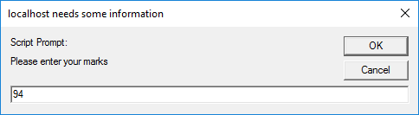

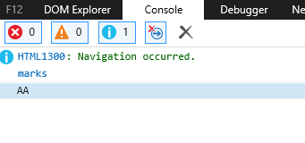

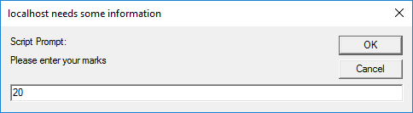

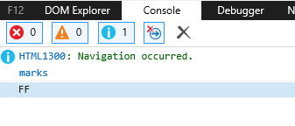

**Question 2**

**Write a JavaScript program to display a multiplication table of 5 and print it in the console in the**

**given format:**

**5*1=5**

**5*2=10**

**5*3=15**

**.**

**.**

**5*20=10**

**Ans.**

<!DOCTYPE html>

<html>

<head>

<title>Multiplication</title>

</head>

<body>

<script>

var number = 5;

for(let i = 1; i <= 20; i++)

console.log(+number+" * "+i+" = " +(number * i));

</script>

</body>

</html>

**Output:**

